**WEEK-8**

|  |  |
| --- | --- |
| **Name :** | **Class :** |
| **Roll no :** | **Date:** |

**PROBLEM STATEMENT:**

1. **Create GRASP creator :-**

**Steps:**

* Create a Class Diagram
* Go to Diagram > New > Select Class Diagram.
* Drag and drop classes from the toolbox onto the canvas.
* Identify Your Creator and Product Classes.
* Draw a Relationship Between the Creator and the Product.

**Output:**

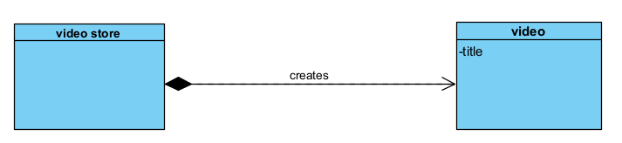

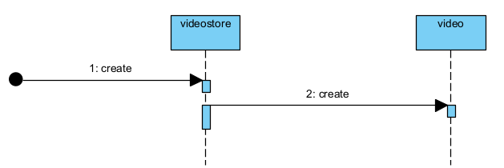

1. **Create expert:**

**Steps:**

* Create a class that owns the data or has the required information.
* Assign the responsibility to this class.
* Draw the method under that class

**Output:**

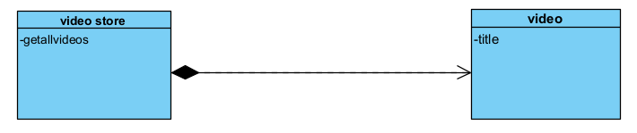

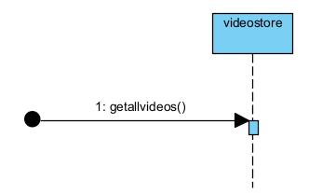

1. **Create controller:**

**Steps:**

* Identify system events from use cases.
* Create a controller class
* In the sequence diagram, let the actor send a message to the controller first.
* Controller delegates to other classes

**Output:**

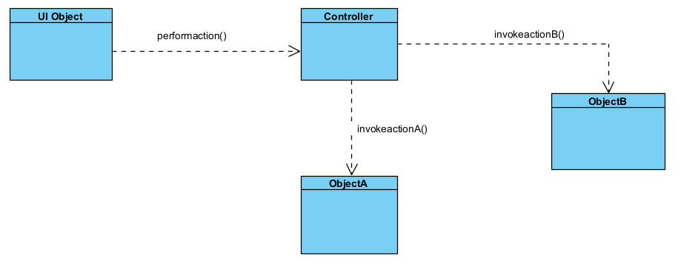

1. **Create lowcoupling:**

**Steps:**

1. Minimize the number of associations per class.
2. Use interfaces or intermediaries instead of direct class access.
3. Avoid calling internal methods of other objects directly.
4. Refactor by introducing abstraction or indirection.

**Output:**

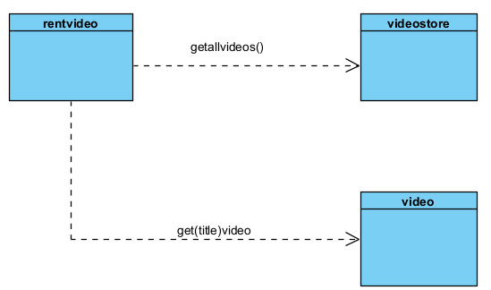

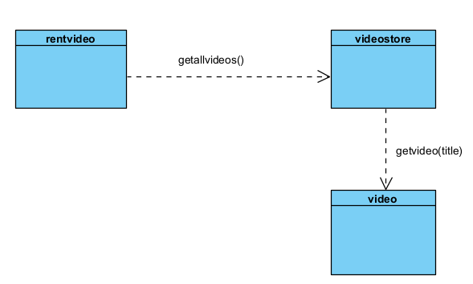

1. **Create high cohesion:**

**Steps:**

1. Group related behavior in the same class.
2. Split classes if they do too many unrelated things.
3. Make sure each class has a clear single purpose.

**Output:**

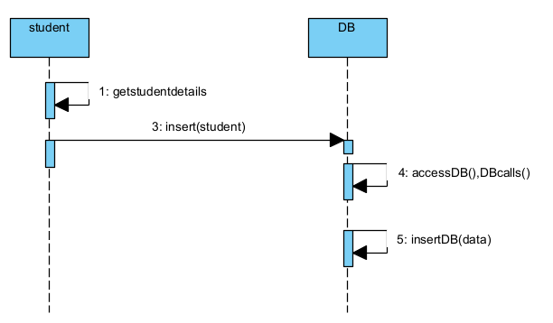

**F) Create low cohesion:-**

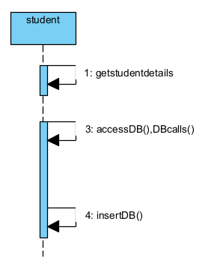

**G) Create polymorphism:**

**Steps:**

* Create an interface or abstract class with common methods.
* Add concrete subclasses that implement/override those methods.
* In client class, depend on the interface, not the concrete types.

**Output:**

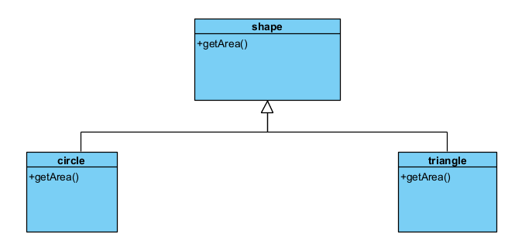

**H) Create indirection:**

**Steps:**

* Create a mediator/helper class .
* Route communication through this class to **decouple** sender and receiver.
* Update the sequence diagram to show indirect messaging.

**Output:**

